MOTOR CODE LOGIC 1 HAS BEEN MODIFIED TO LOGIC 1.1 HERE.

LOGIC 1.1 IS JUST LIKE LOGIC 1 BUT ELIMINATES THE DOUBLE PEAKED FUNCTION RESULTING IN SMOOTH UN-NOTICEABLE DIAGONAL TRANSITION.

LOGIC 1 WAS BASED ON SUM OF TOTAL POWER BEING DISTRIBUTED BUT IN LOGIC 1.1 THIS IS CHANGED TO A MOTOR HAVING INDIVIDUAL POWER AND THE OTHER HAVING A PERCENTAGE OF THAT PARTICULAR POWER .

SO IF A MOTOR HAS POWER ‘T’ OTHER HAS SOME PERCENTAGE OF THIS ‘T’. RATHER THAN REGULATING TOTAL SUM.

THIS MAKES THE INTERFACE VEY INTUITIVE AND MOTOR DIRECTION DON’T SUDDENLY CHANGE ON DIAGONAL OR BASE.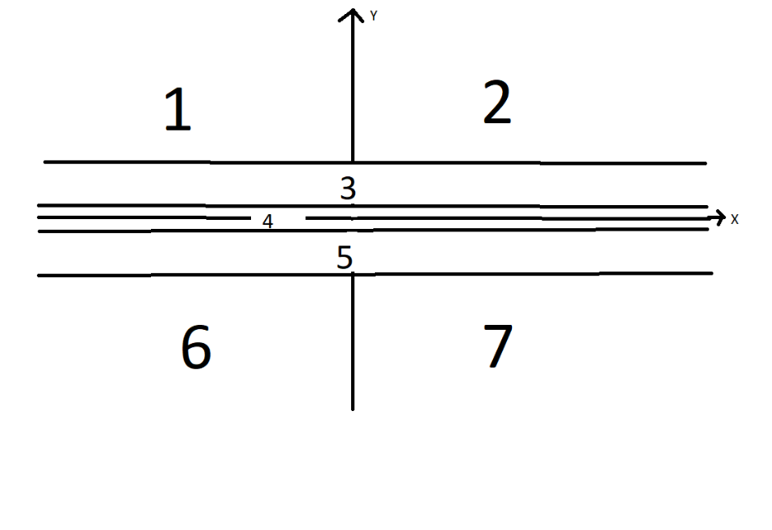

BELOW IS A PICTURE OF ZONE 2

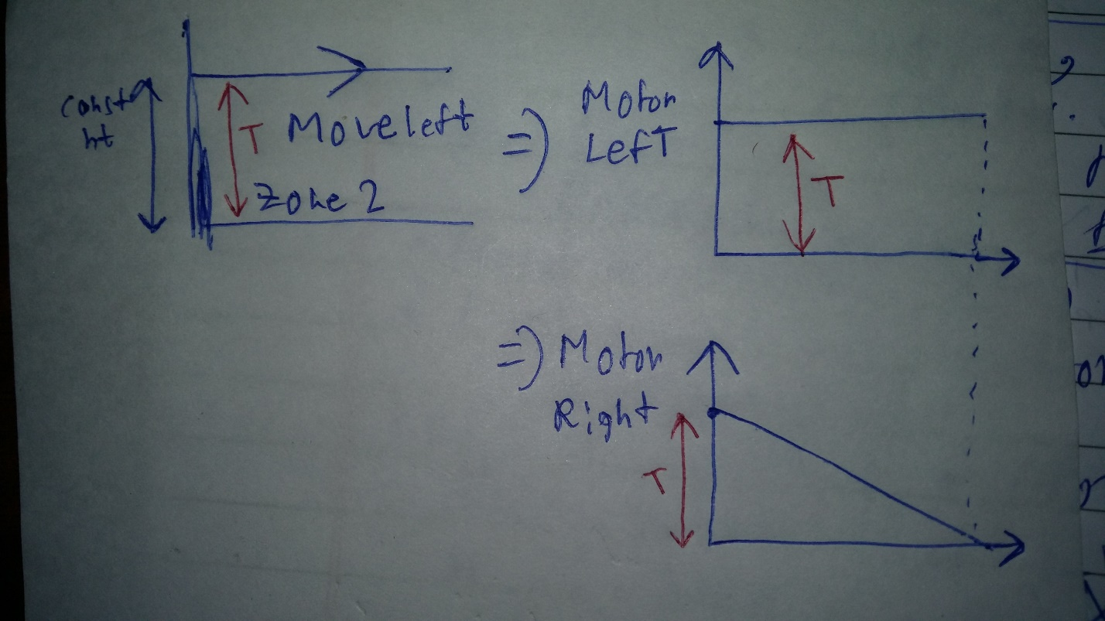

RIGHT MOTOR IS POWERED DOWN MORE AND MORE AS JOYSTICK MOVES TO THE RIGHT.

THIS IS NOT SUITABLE FOR A ROVER WHOSE MOTOR DRIVER "BRAKES" WHEEL IN OFF TIME .

BECAUSE IN CORNERS OR EDGES ONE MOTOR IS 0 POWERED.

* SUITABLE FOR MOTOR DRIVERS WHICH SUPPORT COAST MODE

* THIS CODE CAN BE MODIFIED TO SUIT BRAKE TYPE MOTOR DRIVERS SIMPLY BY MODIFYING THE FUNCTION AND NEVER LETTING A SIDE POWER DOWN TO ZERO WHILE THE OTHER SIDE IS STILL POWERED. THE SIDE BEING POWERED DOWN MAY REACH A MINIMUM OF 20PERCENT FOR EXAMPLE. MAPPING WOULD BE DONE ACCORDINGLY.

SAME COMMENTS ADDED IN CODE TOO 17DEC

TOP RIGHT HALF OF JOYSTICK PLANE SHOWN WITH THE MATHEMATICAL FUNCTION USED.

NOTE THAT ZONES BELOW X AXIS ARE IN REVRSE AND DEAD ZONE IS STILL PRESENT IN 1.1

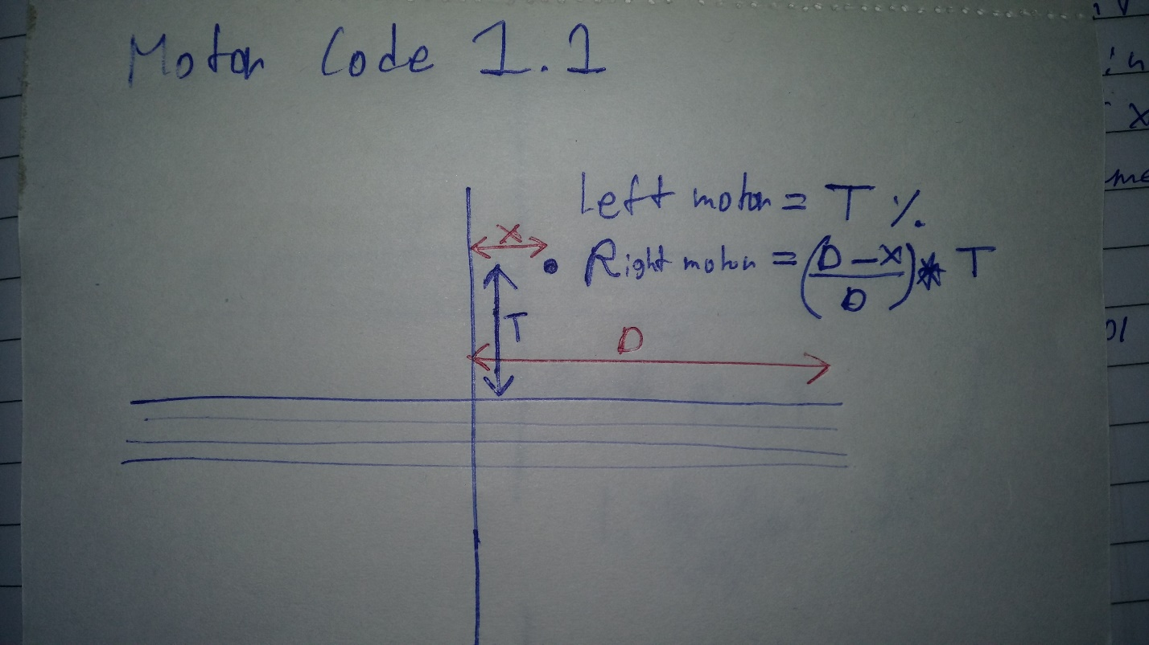

BELOW ARE THE OTHER 3 MAJOR ZONES.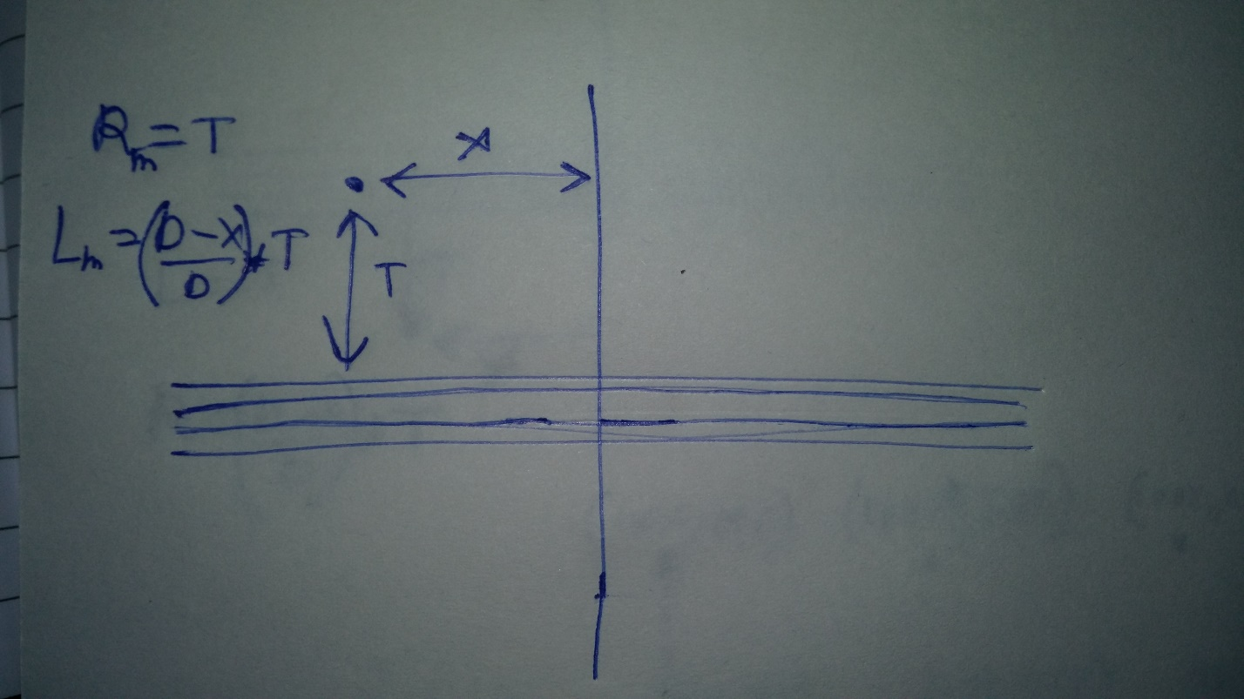

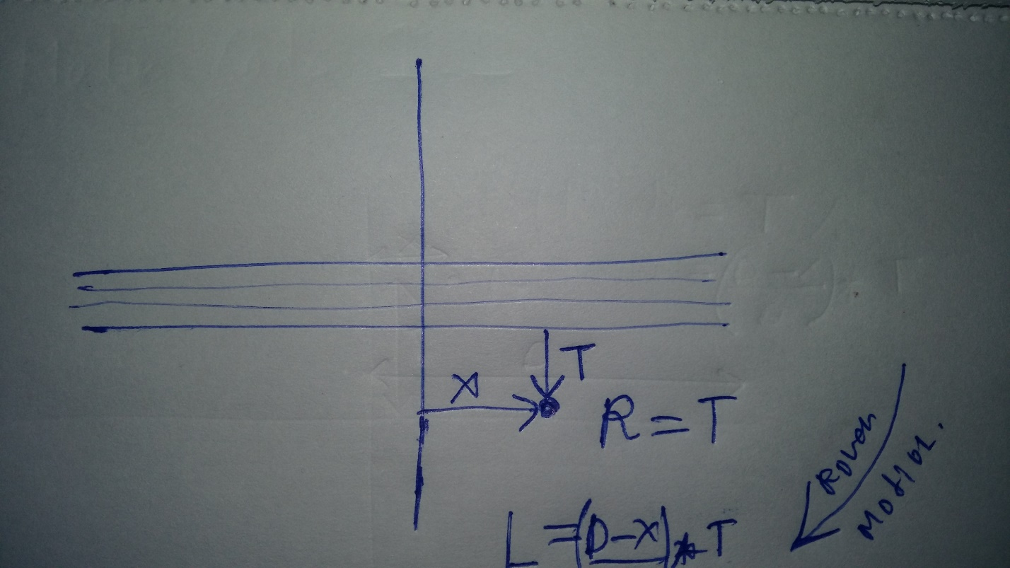

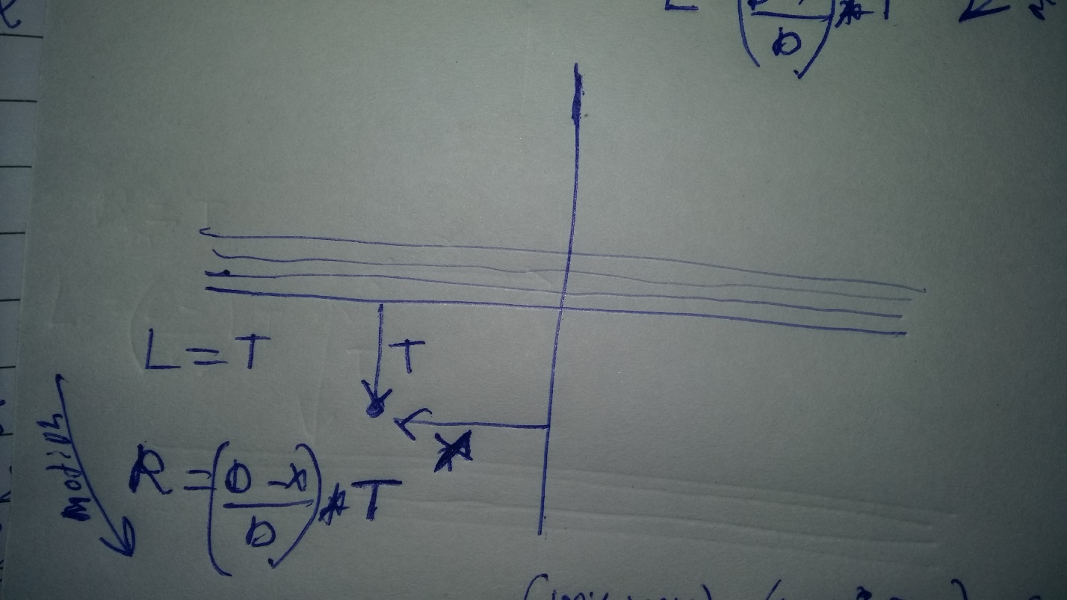

ONE MORE EXAMPLE OF ZONE 2 WHICH IS UPPER RIGHT JOYSTICK PLANE WITH PRACTICAL PWM DUTY VALUES.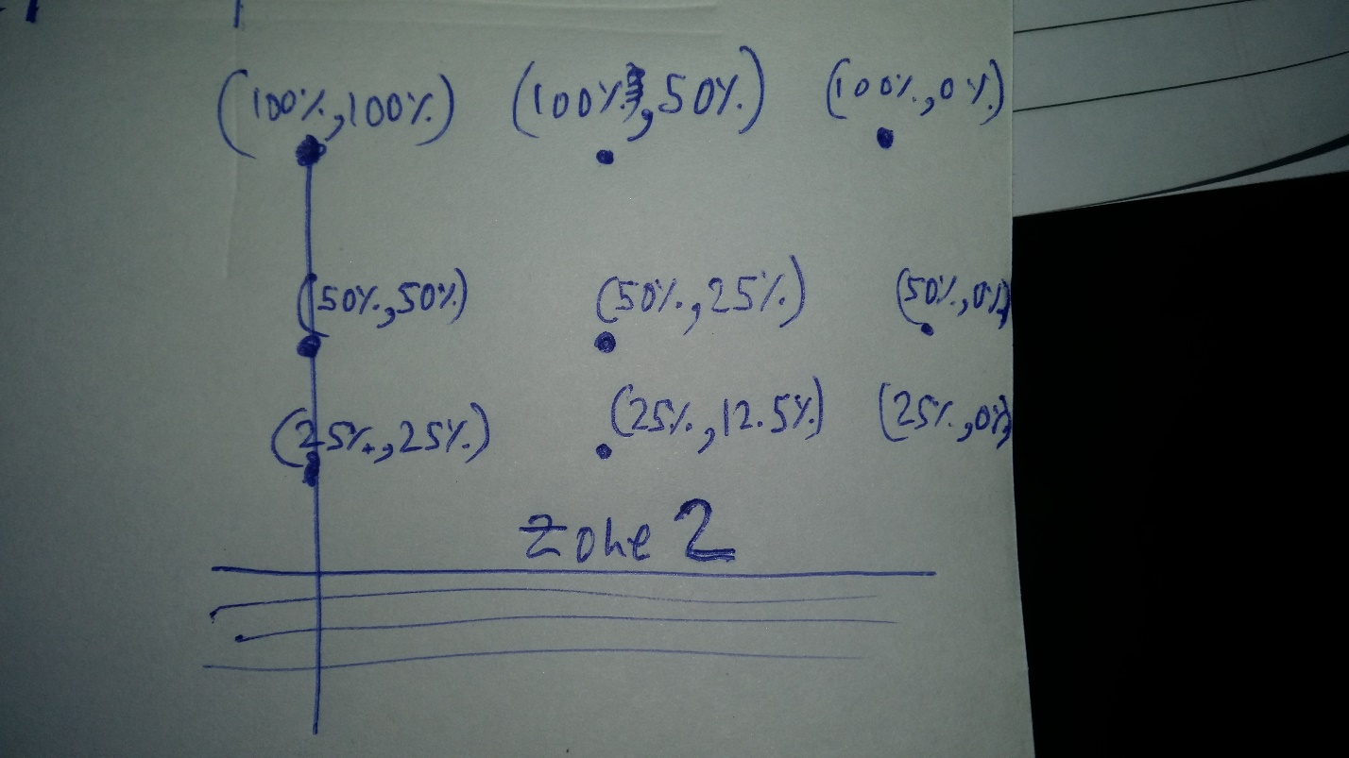

NOTE A LOT OF THE JOYSTICK MAY RESULT IN "DEAD" MOVEMENTS AS MOTOR POWER(EXMPL 15/255) MAY NOT BE ENOUGH TO START MOVING THE HEAVY ROVER

*IN THAT CASE **VERTICAL** LOWER LIMITS ARE ADJUSTED TO A GREATER THAN 0 VALUE AS DETERMINED BY PRACTICAL TESTS.

NOTE THAT T IS MEASURED AFTER UPPER DEADLIMIT OR BELOW LOWER DEAD LIMIT AND VALUES MAPPED ACCORDINGLY

I WILL UPLOAD VIDEOS OF WORKING WHEN INTERNET FIXES ITSELF